Managing doctoral project stakeholders

Stakeholders are individuals or organisation with an interest in a doctoral project’s progress or outcomes. They often provide resources, expertise or support and can influence both the success and risks associated with the project.

Encouraging doctoral candidates to map their stakeholders can be a valuable exercise. It helps them reflect on who matters to their research and plan how they will engage with them throughout their research. It also highlights that different stakeholders will require different types of communication and engagement, depending on their level of interest and influence and the stage of the project.

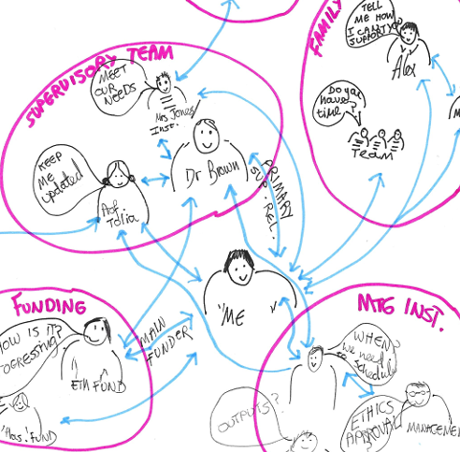
Mapping Stakeholders
Mapping can be done in a list format or visually, depending on what works best for the doctoral candidate.

A visual approach can be particularly effective. For example:
- Circles can represent organisations
- Key groups and individuals can be identified
- The size of images and text can indicate
relative importance
- Lines can show relationships or dependencies
- Notes and annotations can highlight key concerns,
expectations, or communication needs

This kind of map helps candidates see the broader landscape of their project and identify where attention is most needed.

Power and Interest
Once stakeholders are identified, candidates can assess their levels of power and interest. Using a power/interest grid is a useful tool for this, helping to clarify how best to manage the different relationships.

Power
High

Low
Keep Satisfied | Manage Closely
Monitor | Keep Informed
Low Interest High
Reviewing Stakeholders
As the project evolves, so too will the relevance and influence of some stakeholders. Individuals and organisations that were central to the project at the beginning may become less involved or influential, while new stakeholder may become very important. For this reason, doctoral candidates should be encouraged to revisit their initial stakeholder mapping, at points during the project. Regular review will help ensure engagement remains appropriate, and important relationships are not overlooked.

